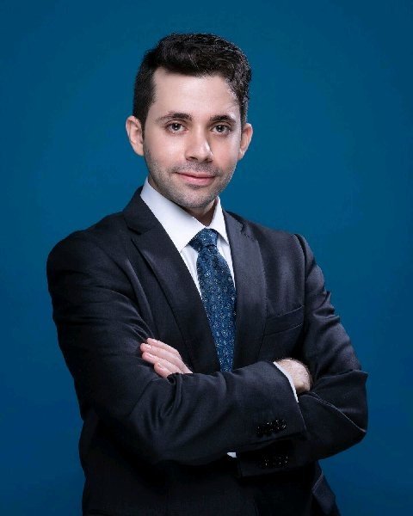**EDEN RABBIE**

Director of Growth & Analytics

Phone: +971 50 138 5522

Email: [aerabbie@gmail.com](mailto:aerabbie@gmail.com)

Languages: English (Fluent), Arabic (Fluent), Japanese (Fluent)

Nationality: Egypt

Marital status: Not Married

Location: Dubai, United Arab Emirates

Business growth professional with **marketing** and **product** managerial experience, **data science** background, and deep practical know-how of risky ventures and **tech** **startups** in UAE.

Japanese-trained. For 10 years I have been building and implementing practical solutions to grow B2B, B2C and B2G businesses as well as government initiatives in MENA, where I delivered and continue to deliver value with businesses, the Japanese government and UAE government.

Certified Six Sigma and CIM Diploma with subject matter expertise in lean startup framework, sixth sector industrialization and UAE startup ecosystem allow me to make relevant contribution in both worlds of tech startup hypergrowth and SME cautioned sustainability, ensuring that growth objectives are achieved more reliably and not by chance.

I led and worked cross-functionally with 68 businesses from all the standard business models to:

* Identify their market dynamics;
* Set their KPIs and metrics system;
* Manage go-to-market and gain traction;
* Manage and retain customers; and
* Scale their marketing, product and operations.
* Today, they serve 530k users and 22k clients.

My most recent achievement is leading a growth team in a government accelerator to improve the quality of its programs 133% and increase its output of quality startups 300%, with a zero-dollar increase in development budget and 40% cut in human capital. (Crunchbase are building a case study about this.)

My objective is clear: to create real impact that makes businesses grow faster, reliably and sustainably, in a way that can be measured, expected and coherently reported to stakeholders.

# **SUMMARY**

Oct 2018 to Nov 2019 **Venture Growth Associate – “Growth Lead”**

*Shurooq – Sharjah Investment and Development Authority* (Sharjah, UAE)

*Sharjah Entrepreneurship Center – Sheraa*

*– Client-facing, in addition to an internal role to improve the department*

Jul 2017 to Sep 2018 **Growth, Strategy and Product Marketing Manager**

*Netaq* (Abu Dhabi, UAE)

Apr 2009 to Jul 2017 **Consultant**  
*SunFlare Co., Ltd.* (Tokyo, Japan)

# **PROFESSIONAL EXPERIENCE**

**Venture Growth Associate – “Growth Lead”**

Oct 2018 – Nov 2019

*Shurooq – Sharjah Investment and Development Authority (Sharjah Entrepreneurship Center – Sheraa)*

Sharjah, United Arab Emirates

My role consists of two types of operations:

1. **Internal operations**

Program/product management; business development

1. **Startups operations**
2. Supervise, coach and help in execution, mainly in marketing, hiring and business growth.
3. **Internal operations**
   1. Delivered **170% of annual KPI's** in just 5 months
   2. Top **NPS Score** in the department, thanks to 75% Promoters
   3. Managed 28 client accounts directly, and developed the standard framework for account management of 78 businesses in the department
   4. Created communications and reactivation effort to retain churned and inactive clients
      * Reactivated 62% of inactive and churned clients
      * Successfully converted 38% into retained clients who enrolled in our new programs
   5. Led a growth team of 5 people to scale up the incubator and accelerator programs to output 300% more quality startups, with 133% improvement in quality, with zero-dollar increase in development budget and 40% cut in human capital
      * Gap analysis and market research to identify investors and startup founders needs
      * Formulate program’s strategy, positioning, vision and business goals
      * Set department’s KPIs
      * Define program’s scope and outline curriculum and processes
      * Create the program’s product roadmap and iterations backlog until 2021
      * Assist programs manager create buy-in from top management
      * Manage a team of 5 (1 senior, 4 junior) + 3 interns to develop the program
      * Negotiate with software and tools vendors to provide tech stack for startups
      * Build and execute communications and engagement action plan
      * Execute marketing collateral (presentations, website and social media copy)
      * Develop automated qualification system to screen +110 applicants
      * Assist in organizing pitch day, judge panel, commencement event and demo day
      * Lead program sessions with startup founders
      * Assist in pitch training sessions
      * Maintain relationship with startups in the Sheraa community to reduce risk of churn
      * Deliver 44 coaching and mentorship sessions to startups in the Sheraa community
      * Manage and train 3 interns on content marketing, automation, and market research
   6. Delivered 3 programs
   7. Created and delivered 5 workshops and special sessions, which received 200 attendees  
      (The Impact of Bottom of the Funnel in B2B and B2C; Startup Lifecycle; The Voice of the Customer; Six Sigma in Startups & SMEs; Introduction to Growth Marketing)
   8. Spread data-driven growth mindset across the organization, adopting it into corporate culture
4. **Startups operations**
   1. **B2B Marketing & B2C Marketing**
      * Digitized the sales cycle of 8 businesses
      * Formulated 16 marketing strategies
      * Managed 26 campaigns from across the funnel (from demand generation to retention), including positioning and budgeting

(Actively contributed to the execution of +25 of the campaigns and experiments)

* + - Mapped 12 customer journeys
    - Installed digital marketing infrastructure in 15 businesses (including CRM and Email Automation)
    - Managed funnel CRO implementation in 9 businesses (4 B2B)
  1. **Product Marketing and Growth Marketing**
     + Activated growth teams and growth experimentation in 12 businesses to generate insights and learnings to be used for iterating marketing and product
     + Designed 49 growth hacking experiments

(Actively contributed to the execution of +25 of the campaigns and experiments)

* + - Directed implementing marketing automation and digital transformation (marketing + product marketing) in 6 businesses
    - Implemented metrics framework and tracking system in 12 products (Google Analytics, Firebase, Inapptics and Hotjar)
  1. **Business Growth, Fundraising & Investor Relations**:
     + Managed fundraising strategy and investor relations for 11 startups
     + Managed/helped execute 23 go-to-market strategies
     + Managed/helped execute 3 expansion strategies to Saudi Arabia
     + Managed/helped execute 15 marketing discovery campaigns
     + Set the scaling roadmap for 6 businesses

**Growth, Strategy and Product Marketing Manager**

Jul 2017 to Sep 2018

*Netaq*

Abu Dhabi, United Arab Emirates

* Coordinated and worked closely with CEO, C-Level, and cross-functional teams
* Contributed to improving onboarding process conversion rate by 50%
* Conducted data-driven market research to identify user needs and gain insight on market-specific trends for digital product
* Managed product strategies; vision and product positioning to ensure competitive advantage
* Developed product life cycle and roadmap
* Developed KPI’s and metrics to assess the success of the product
* Presented strategy and created buy-in with the board and parent investment group board
* Coordinated and worked closely with technical, marketing and sales teams, and helped create marketing strategy and marketing campaigns
* Reported directly to CEO on 8 key metrics on a daily, weekly and monthly basis

**Consultant**

Apr 2009 to Jul 2017

*SunFlare Co., Ltd.*

Tokyo, Japan

* Delivered 100 successful projects to governments, corporations and higher education institutes, with focus on assisting in successful global expansion
* Participated in providing training conducted by Japan External Trade Organization (JETRO), Japanese Official Development Assistance (ODA) and Japan International Cooperation Agency (JICA) to government officials and foreign countries officials in:
  + SME development, assistance and promotion
  + Professional management and operations efficiency
* Helped secure deals with JETRO, ODA and JICA (see above)
* Conducted market research for client global expansion purposes
* Advised on client positioning and market segmentation

# **TRAINING AND PROFESSIONAL AFFILIATION**

CIM Diploma in Professional Marketing (Digital Marketing) – L6  
*Chartered Institute of Marketing, Cambridge Marketing College, United Kingdom (*2020)

Machine Learning Certification  
*Stanford, United States*

Lean Six Sigma Yellow Belt  
*Technische Universität München TUM - School of Management, Germany*

Member,*Chartered Institute of Marketing, United Kingdom (2019)*

# **EDUCATION**

**Master of Linguistics** (Coursework), focus: Natural Language Processing

*Ain Shams University, Cairo, Egypt* (2010)

**B.A. in Japanese Linguistics**, focus: Semiotics

*Hiroshima University, Hiroshima, Japan and Ain Shams University, Cairo, Egypt* (2006)

# **URLs**

Medium

<https://medium.com/@edenrabbie/>

LinkedIn

<https://www.linkedin.com/in/edenrabbie/>

Check my posts (under “See all activity”) for data insights on tech investment and startups in MENA based on historical records since 2011.

Testimonials from 12 clients (CEOs and co-founders)

<https://www.slideshare.net/slideshow/embed_code/key/GfsO6XAKYvkQo2>